Super Irshad! Pandas-kku maaraadhu oru nalla decision. Oru Data Analyst-ukku Pandas dhaan "Right Hand" maari.
Neenga ippo manual-a loop panni, list create panni seidhathu ellathaiyum, Pandas romba easy-a, "DataFrame" endra structure-la kondu vandhu kudukkum.
📖 Lesson 17: Introduction to Pandas (The Power Tool)
Pandas-la namma "DataFrame" nu solluvom. Idhu Excel sheet-ai Python-kku kulla kondu vandha maari irukkum.
🛠️ Code: Database-ai Pandas-la paarkka
Adhu eppadi work aagudhu nu oru chinnna demo paarkkalam. pandas_demo.py nu file create pannunga:
Python
import sqlite3
import pandas as pd # Pandas-ai import panrom

# 1. Database-kku connect panrom
conn = sqlite3.connect('my_shop.db')

# 2. SQL query-ai Pandas-oda 'read_sql_query' function vachi read panrom
df = pd.read_sql_query("SELECT * FROM Sales_Report", conn)

# 3. Ippo idhai oru DataFrame-a print panrom
print("Pandas DataFrame:")
print(df)

conn.close()
🔍 Enna Nadakkudhu?
- pd.read_sql_query(...): Ithu dhaan magic! Neenga munnadi manual-a cursor, fetchall, loop nu panna ellathaiyum, intha single line automatically senjudum.
- df (DataFrame): Ithu dhaan Pandas-oda Table. Idhula rows, columns, headers ellam excel-la irukkuradhai pola arrange aagidum.
💡 Teacher's Note:
Neenga munnadi keta "Row 0" matrum "Row 1" nu kavalai pada vendiya avasiyame illa! Pandas-la neenga direct-a df['Sales'] nu column perai sonna pothum, Python auto-va eduthukkum.
Unga Task:
- pandas library unga system-la illana, terminal-la pip install pandas nu type panni install pannunga.
- Indha code-ai run pannunga.
- Output excel sheet maari azhaga vandhurukaa nu sollunga!
Ready-a Irshad?
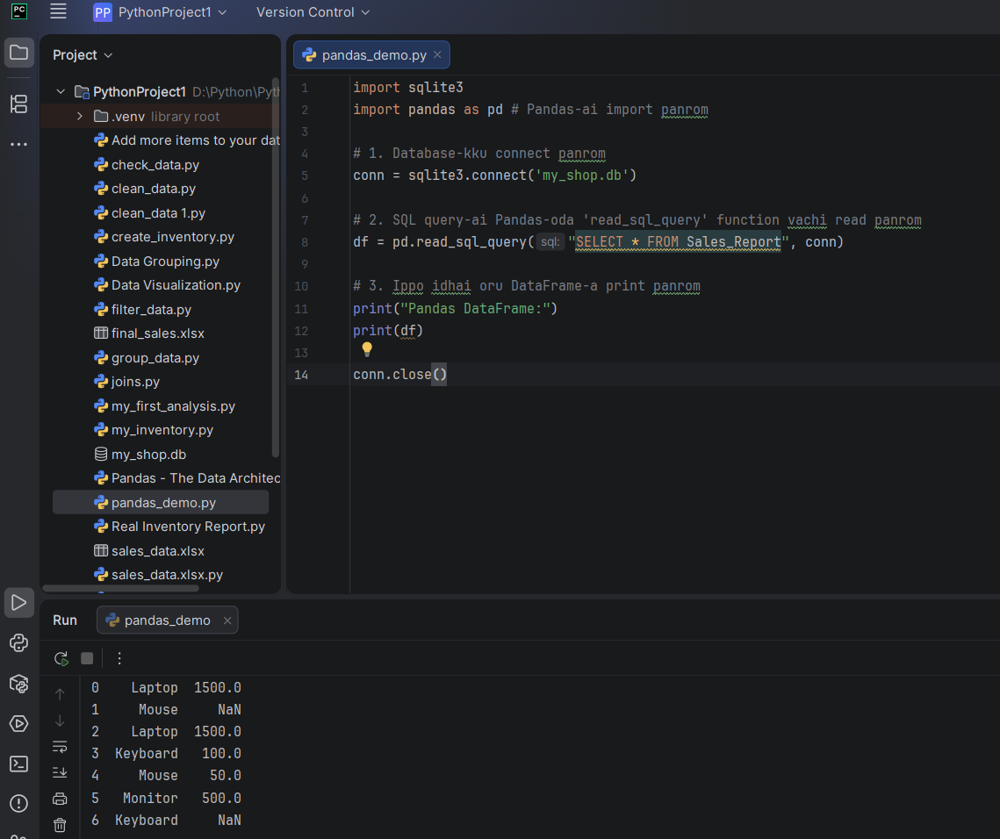
df = pd.read_sql_query("SELECT * FROM Sales_Report", conn) ENAKKU INDA LINE LA IRIKIRA ONDUME SUTHAMA VELANGAILLA
Irshad, kavalai padaatheyenga. Intha line thaan "Pandas"-oda moolai. Idhai "Bridge" (Paalam) maari nenaichukonga.
Namma database my_shop.db-la irukkura data-vai, Python-oda Pandas format-kku (DataFrame) kondu varum "Oru Palam" dhaan intha line.
Ippadi visualize pannunga:
🔍 Line-ai Prithu Pakkalam:
df = pd.read_sql_query("SELECT * FROM Sales_Report", conn)
- df =:
  - Ithu oru "Box" (Variable). Database-ilirundhu varra ellathaiyum intha box-kulla dhaan namma store panrom. df na "DataFrame" nu artham.
- pd.:
  - pandas library-ai thaan namma pd nu short-a koopdurom. Idhu oru command kutti.
- read_sql_query(...):
  - Idhu dhaan "Action". Ithu database-ai paathu solludhu: "Hey database, un kitta irukkura query-ai read panni enakku kudu."
- "SELECT * FROM Sales_Report":
  - Ithu ungalukku therinja SQL query. "Sales_Report table-la irukkura ellathaiyum ( * ) eduthu kudu."
- conn:
  - Idhu "Key" (Door opener). Database-kku connect aagura key-ai, intha function-kku kuduthu dhaan namma data-vai edukkrom.
💡 Oru Real-life Example:
- Database: Oru periya library-la irukkura file.
- SQL Query: "Andha file-ai eduthu kudu" nu library-kku kudukkura request.
- read_sql_query: Andha file-ai eduthu, unga desk-la "Excel Sheet" maari neatly arrange panni vaikura Librarian.
- df (DataFrame): Ippo unga desk-la irukkura andha clean-aana Excel sheet.
Yen intha line mukkiyam? Munnadi namma cursor.execute(), cursor.fetchall(), loop nu 3-4 line ezhudhunom. Aana intha ore line ellathaiyum automatic-a seiyudhu.
Ippo puriyudha Irshad? Librarian-oda velaiyai intha code seiyuthu. Idhu clear-a irukka, illana innum breakdown pannalama? Arumai, Irshad! Neenga success-a "Pandas DataFrame"-ai display panniteenga. Paathiya, database-la irundhu data-vai avvalavu azhagana table format-la Pandas kondu vandhuduchu!
🌟 Oru Mukkiyamaana Observation
Unga output-la NaN endru kooduriya sila values irukku.
- NaN na "Not a Number" (illana missing value) nu artham.
- Idhu dhaan Pandas-oda specialty—database-la irukkura missing values-ai kooda adhu kandupidichi, namakku NaN nu correct-a kaattudhu.

